Description
CLICK HERE FOR THE BLUEPRINT
This is the full break down on how to prepare the report for clients when its time to bill them for the pending amount.
The way this reporting works is that each client has their own reporting sheet. Every month you will go in a make scenario and pull the data from the main sheet onto their own sheet.
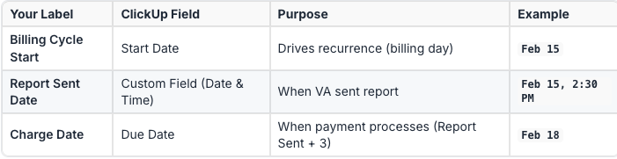

0: Understanding Billing Tools
Two primary tools are used in this process: ClickUp for task management and the Waiz Board for generating reports.

0.1 : Click up Billing List
The ClickUp Billing List is used to track client billing cycles and invoice due dates. It is organized into two main tabs:
1. Accounts Tab: This tab contains a list of all clients, considered "Parent Tasks." The "Billing Day" field in this tab indicates the start date of each client's billing cycle.
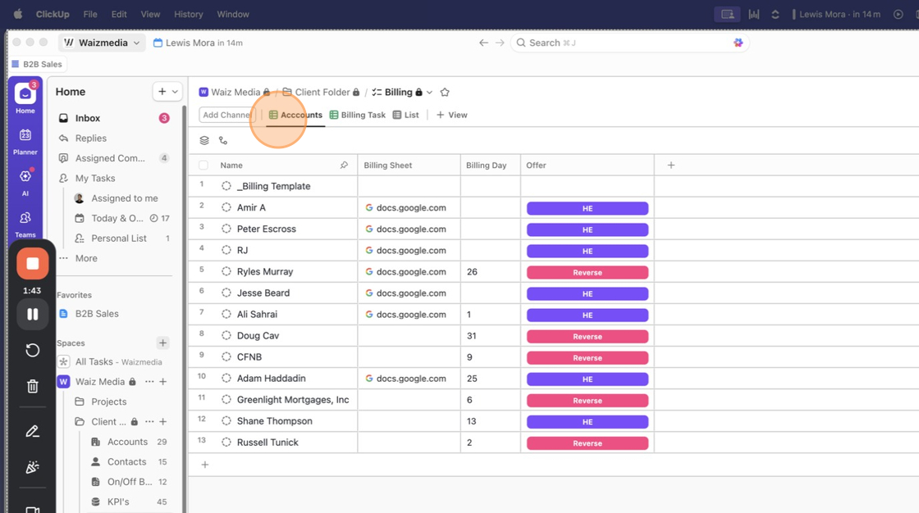
2. The Billing Tab: This tab contains individual, recurring "tasks" that indicate when a client's invoice is due. The generated reports and any relevant details are uploaded and logged within these tasks to maintain a complete history.
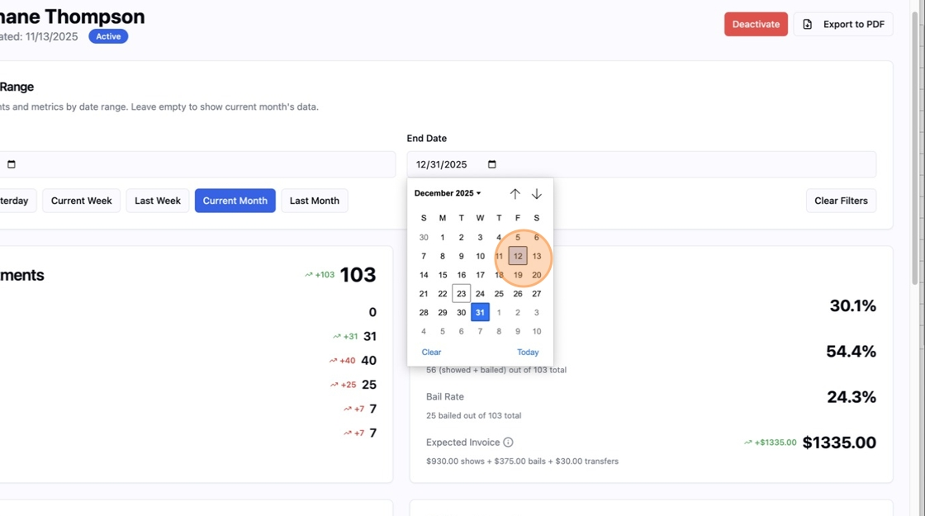

0.2: Waiz Board
The waiz board is where we pull the reports. And Check the client KPI's and can pull the reports.

Step 1: Prep
On this step, all you're doing is looking for the clients billing date. For this, you go to the billing list in the Client folder.
- Navigate to the "Client" folder in ClickUp and open the billing list.
2. Go to the Accounts Tab to identify the client's billing start date, which is listed in the "Billing Day" column.
3. Determine the correct date range for the report. The start date will be the "Billing Day" of the previous month, and the end date will be the day before the current month's "Billing Day".

Step 2: Pull Report From Waiz Board
- Go to board.waizmedia.net
- Select the Sub-accounts Tab
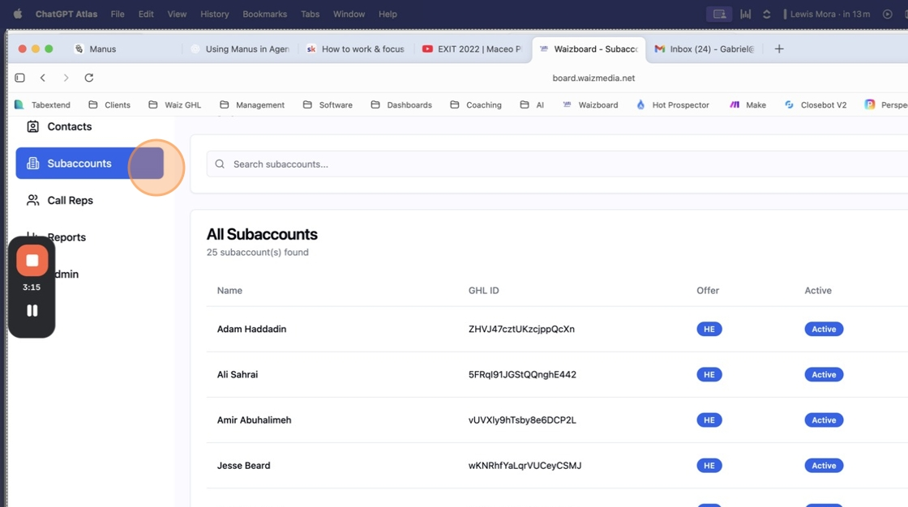
3. Select "View" Under which client you are doing the report on

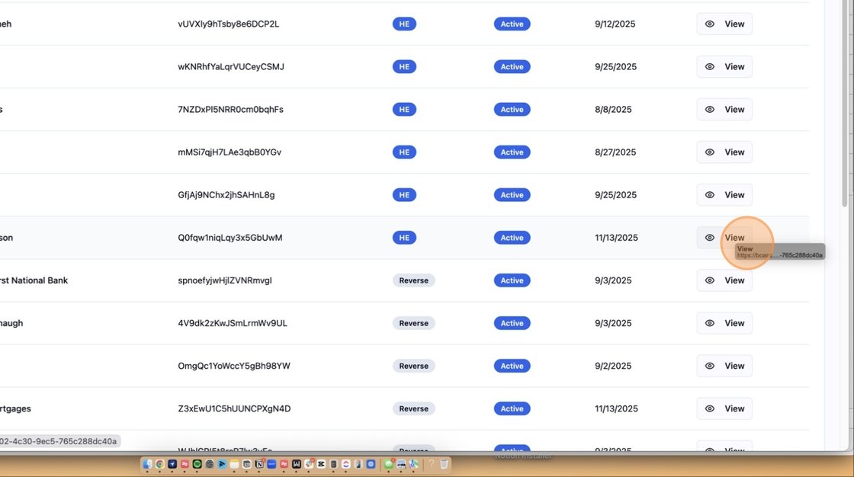
4. Update the start of billing date and end date
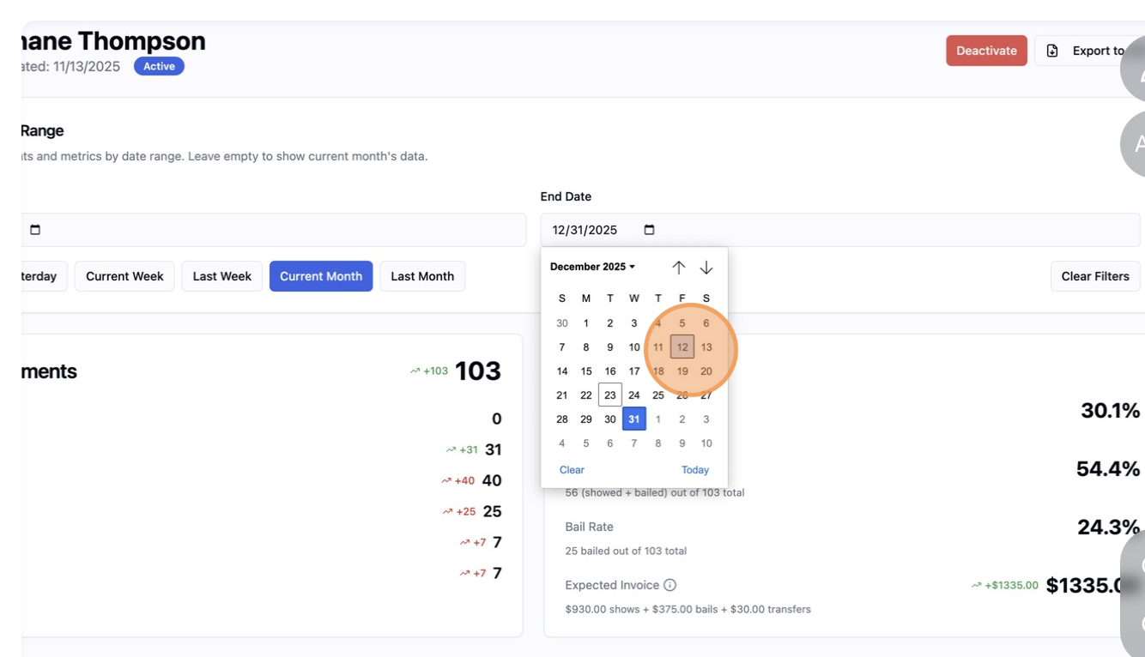
5. Once the dates are updated, you're ready to export as a PDF
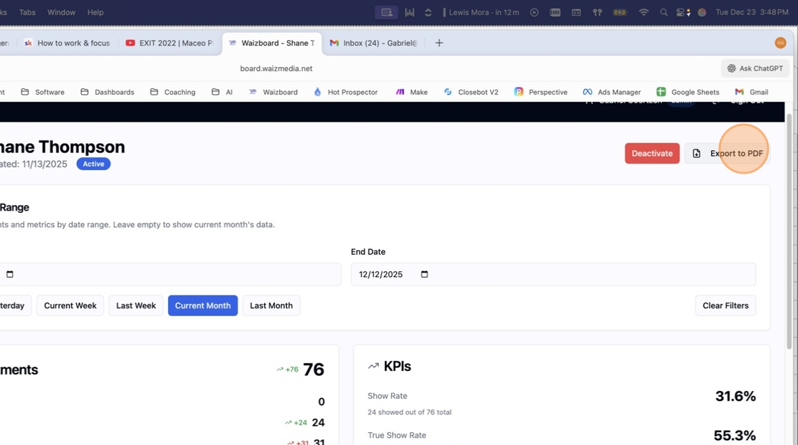

Step 3: Email Client
- Email Client with this script below
Subject: Your Monthly Performance Report 👀
Hi [Client Name],
Hope you’re doing well and had a great month.
Just wanted to give you a quick heads up that your monthly performance report is ready... you’ll find it attached here. It breaks down everything from the past month and the work we’ve done together.
Take a look when you get a chance, and if you have any questions or notice anything that doesn’t look right, just let us know within the next 3 business days. Happy to walk through anything with you.
If we don’t hear back within that window, we’ll assume everything looks good and move forward with billing the card on file for the amount shown in the report.
Appreciate you as always, and excited to keep building momentum this next month.
Best,
[Your Name]
- Slack Message the client with the template below
Hey [Client Name]! 👋
Just dropped your monthly performance report in your inbox. Give it a look when you have a minute.
If you have any questions or want us to clarify anything, just let us know within the next 3 business days 👍
Otherwise, we’ll move forward with billing as outlined in the report.
Appreciate you!

Step 4: Update Task
Now that everything is calculated. Update the task with the amounts on there and disposition the status to "in progress"
- Open the corresponding client task in the Billing Tab in ClickUp.
- Update the task with the amounts from the report.
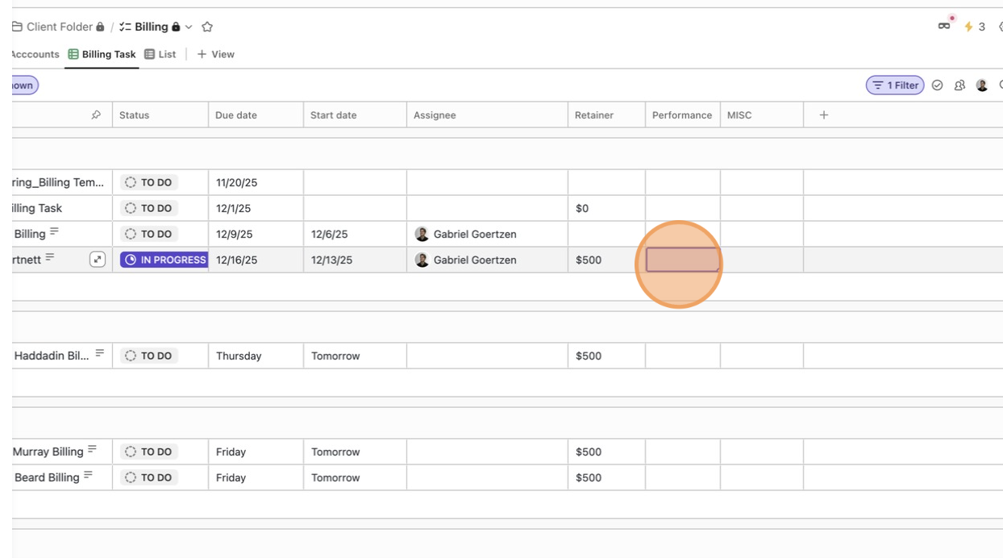
- Upload the document into the task
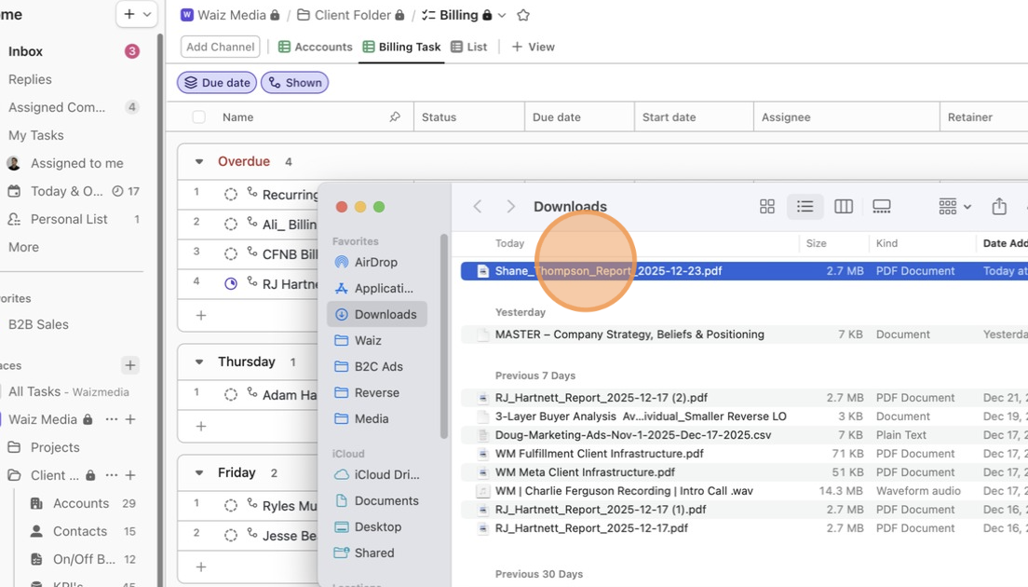
- Change the task status to "In Progress."
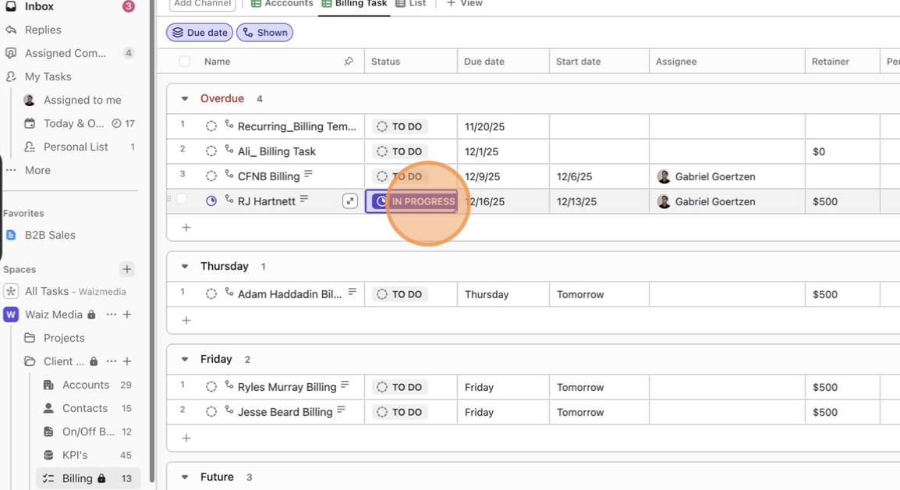

Step 5: Client Objects (Optional)
If the client objects, investigate more and if client is correct. Update the click up task, and write a note in there with screen shots of the clients dispute

